**Database and Management System Lab**

NAME: PRIYANSHI VARSHNEY

ROLL NO: R2142230042

SAP_ID: 500119947

BATCH 2

B.TECH CSE, SEM-III

**EXPERIMENT 10**

**Title: Create the following views in SQL on the COMPANY database schema presented in Experiment 2**

**1. A view that has the department name, manager name, and manager salary for every department.**

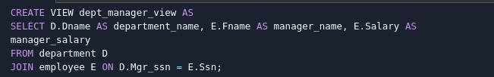

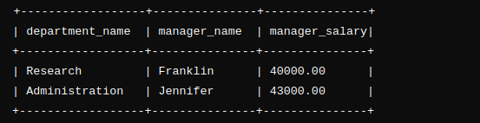

**2. A view that has the employee name, supervisor name, and employee salary for each employee who works in the ‘Research’ department**

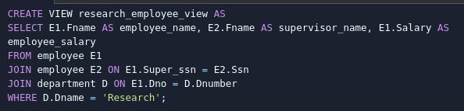

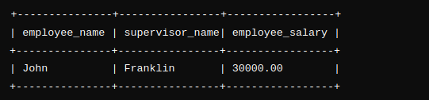

**3. A view that has the project name, controlling department name, number of employees, and total hours worked per week on the project for each project.**

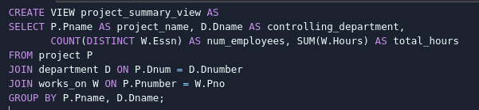

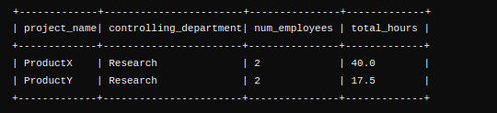

**4. A view that has the project name, controlling department name, number of employees, and total hours worked per week on the project for each project with more than one employee working on it.**

